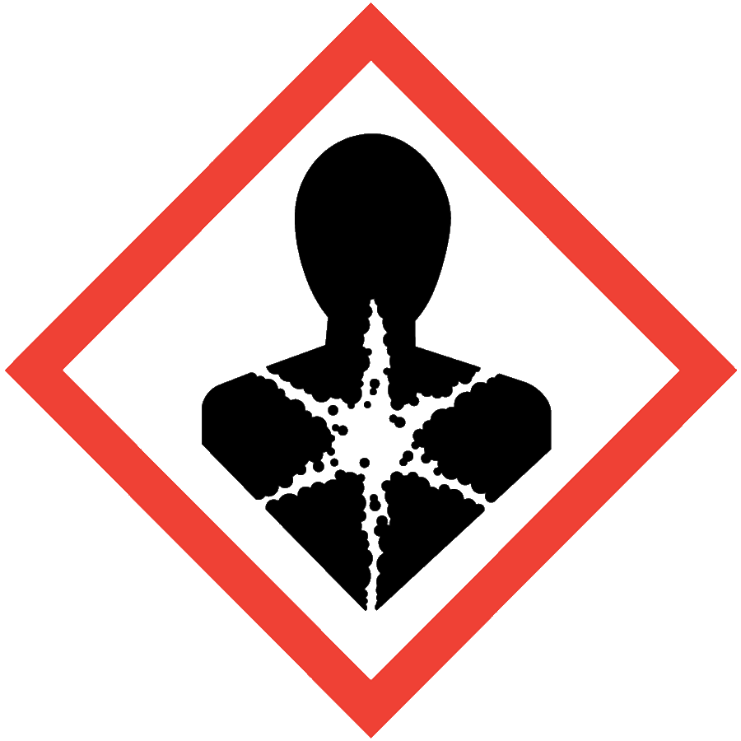
CARCINOGENS
Carcinogens are chemicals or physical agents that cause cancer or increase its incidence. Carcinogens are chronically toxic substances: they cause damage after repeated or long-duration exposure, and their effects may not be immediately apparent but only become evident after a long latency period. The resources below can be used to determine whether a material is a carcinogen:
- Department of Labor & Industries Carcinogen List (WAC 296-62) (Note: This SOP does not cover listed carcinogens. Materials on the L&I list require chemical-specific SOPs.)
- Annual Report on Carcinogens by the National Toxicological Program, including substances listed as “known to be carcinogens” or “reasonably anticipated to be carcinogens”
- The International Agency for Research on Cancer, including Group 1, 2A and 2B chemicals
- Section 11 of the material’s safety data sheet (SDS)

ENGINEERING/VENTILATION CONTROLS
- Chemical fume hood or glovebox
If the process/experiment cannot be performed in a fume hood or glovebox, contact the ASO for an assessment to determine necessary controls.

SAFE WORK PRACTICES
- Before beginning work, prepare an experiment plan that describes the safety considerations for each step of the process, including disposal (i.e., cradle to grave).
- Know the signs and symptoms of exposure to the material before working with it. (Consult the SDS.)
- Follow universal administrative controls described in the Chemical Hygiene Plan.
- Limit the amount of material handled: use the smallest amount possible.
- Work with carcinogens in a designated area.
- Wash hands thoroughly after handling carcinogenic substances.

PPE
- Eye Protection: ANSI Z87.1 safety glasses or goggles
- Body Protection: lab coat
- Hand Protection: protective gloves appropriate for the chemical being used (consult the SDS)
Depending on the risk assessment, a face shield and/or chemical splash apron may be appropriate. Additional PPE may be required if the chemical has additional hazard classification(s).

HANDLING AND STORAGE
- Keep containers closed when not in use.
- Ensure containers are in good condition and compatible with the material.
- Store carcinogens in secondary containers.
- Work with open containers only in the fume hood or glovebox.
  - Use ventilated containment to weigh solid chemicals or use the “tare” method: weigh an empty container, add the chemical to the container in the fume hood, seal the container, remove it from the fume hood and re-weigh it.
- Label the storage location with a hazard warning.
- Avoid all contact with carcinogens, including skin contact and inhalation.
- Consult Sections 7 and 10 of the SDS for chemical-specific storage recommendations.

SPILL AND ACCIDENT PROCEDURE
Consult the Chemical Hygiene Plan for spill and accident procedures.

DECONTAMINATION AND WASTE DISPOSAL
- Decontaminate work areas, fume hoods/gloveboxes and equipment after each use while wearing proper PPE. Consult the SDS for decontamination procedures. Soap and water are effective for many materials.
- Collect waste in chemically compatible containers labeled with a Seattle University Hazardous Waste Label.
- Segregate incompatible waste streams. Refer to Section 10 of the SDS for specific incompatibilities.
- Consult the Regulated Waste Management policy for more details on waste disposal. Specific disposal recommendations are available in the SDS.

