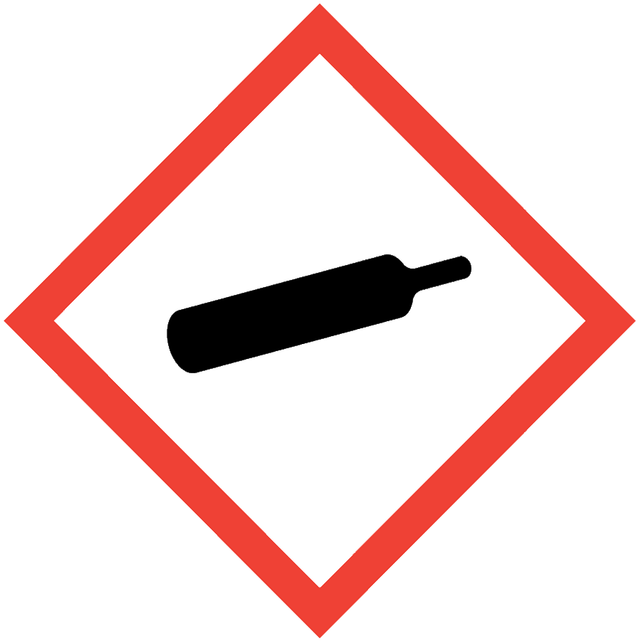
COMPRESSED GASES

HAZARD CLASS DESCRIPTION
The gas cylinders containing compressed can pose a physical hazard if the pressure is released suddenly and violently. Depending on the gas, compressed gases can exhibit many additional physical, health and chemical reactivity hazards ranging from moderate (ammonia) to severe (fluorine gas). Many compressed gases can cause asphyxiation. Some gases have additional hazards such as flammability, toxicity and/or pyrophoricity, which are addressed at the end of this document.

ENGINEERING/VENTILATION CONTROLS
Use and store in a well-ventilated area. At a minimum, adequate general laboratory ventilation must be provided to maintain exposure below safe regulatory limits.
If the compressed gas is a particularly hazardous substance (i.e., carcinogen, acute toxicant and/or reproductive toxicant), work with it in a chemical fume hood or ventilated gas cabinet.
If Permissible Exposure Limits (PELs) may be exceeded, a chemical fume hood or other engineering control is required. PELs can be found in Section 8 of an SDS.
In some cases (e.g., certain toxic gases), gas monitors may be required to prevent overexposure or asphyxiation. Contact the ASO for an assessment to determine if gas monitors are necessary.

SAFE WORK PRACTICES
- Know the signs and symptoms of exposure to the material before working with it. (Consult the SDS.)
- Follow universal administrative controls described in the Chemical Hygiene Plan.
- Ensure that gas cylinders and regulators are in good condition. Do not use cylinders that are corroded, dented or bulging.
- Use a regulator compatible with the gas being used (correct CGA number; CGA fitting reference). Note: flammable gas regulators are reverse threaded.
- Do not use Teflon tape on regulator CGA fittings.
- Ensure the regulator and the gas cylinder CGA connections are clean and there is no gross contamination that could prevent good contact.
- Check connections for leaks using a dilute detergent such as Snoop.
- Use tubing that is chemically compatible with the gas.
- Depending on risk assessment, pressure reliefs may be necessary in systems utilizing compressed gases.

PPE
- Eye Protection: ANSI Z87.1 safety glasses or goggles
- Body Protection: lab coat
- Hand Protection: protective gloves appropriate for the chemical being used (consult the SDS)
Additional PPE may be required if the chemical has additional hazard classification(s).

HANDLING AND STORAGE
- Do not expose gas cylinders to temperature extremes or prolonged sunlight.
- Store compressed gas cylinders with the valve protection cap on when not in use.
- Secure gas cylinders upright to a fixed object using one or more restraints. Best practice is to secure cylinders with two non-combustible restraints at 1/3 and 2/3 of the cylinder height.
- Transport gas cylinders secured to a suitable hand truck with the valve protection cap on.
- Use a freight elevator to transport gas cylinders when available.
- Mark used/spent cylinders as “MT” or “Empty.”
- Separate flammable and oxidizing gases by at least 20 feet or with a fire-resistant barrier wall at least 5 feet high with a fire rating of at least one hour.
- DO NOT use tools on the cylinder valves.
- Consult Sections 7 and 10 of the SDS for chemical-specific storage recommendations.

SPILL AND ACCIDENT PROCEDURE
In the event of a gas leak or accidental release, attempt to close the gas valve if possible and safe to do so; otherwise, evacuate the area and call Public Safety at 206-296-5911.
Consult the Chemical Hygiene Plan for general spill and accident procedures.

WASTE DISPOSAL
Contact vendors to remove cryogen cylinders from the lab.
Lecture bottle-sized gas cylinders can be labeled with a Seattle University Hazardous Waste Label. Request pickup through Facilities Work Order.

REGULATOR USE
Never attempt to attach a regulator to a gas cylinder without hands-on training from a knowledgeable user. These guidelines apply to inert gases; additional considerations for regulator use may be needed depending on the hazards of a gas. Supplement this information with lab-specific protocols and training.

Attaching Regulator to Gas Cylinder
- Inspect the body and main components of the regulator for damage.
- Check the Compressed Gas Association (CGA) regulator fitting and the fitting surface of the cylinder valve for damage. Pay particular attention to the threads, seat and regulator gaskets, if present. Do not use regulator if any damage is observed.
- Remove debris from the treads and seat of the cylinder and regulator. Debris can prevent a proper seal between the regulator and cylinder. Do not use Teflon tape on cylinder fittings.
- Set the pressure of the regulator to zero by turning the pressure adjustment screw counterclockwise (see figure below). Leave at least two threads engaged in the regulator body.
- Close the flow control valve fully in a clockwise direction.
- Hand tighten the CGA fitting of the regulator to the cylinder in a clockwise direction. (Note: CGA fittings on regulators with notches in the middle are tightened in a counterclockwise direction, which is common for flammable gases.)
- Do not force the connection. If the CGA fitting is not easily tightened by hand, stop and reassess to ensure a correct and undamaged CGA fitting is being used.
- Tighten the CGA fitting until snug using a wrench. Do not over tighten.
- Stand on the opposite side of the cylinder from the regulator. Slowly open the cylinder valve clockwise to pressurize the regulator. The cylinder pressure gauge should rise to the full pressure of the cylinder.
- Use a soap solution (e.g., Snoop) to check for a leak at the regulator connection. If a leak is detected, depressurize the regulator, retighten the CGA fitting and recheck connection for leak.
- Once no leaks are detected, turn the pressure adjusting screw clockwise to raise the delivery pressure to the desired working pressure using the delivery pressure gauge. Do not exceed 75% of the maximum delivery pressure for the regulator system.
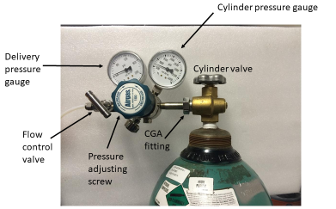
- Check the system for leaks as described in step 10.
- Slowly open the flow control valve to deliver the gas at the adjusted pressure to the system. The delivery pressure may need adjustment.

Removing Regulator from Gas Cylinder
- Close the cylinder valve completely.
- Release the pressure in the regulator/system so that the delivery and cylinder pressure gauges on the regulator read zero. Do not attempt to loosen a regulator from a cylinder while it is still under pressure. If the system has a gas outlet control valve downstream of the regulator, open this valve to release the gas pressure from the delivery line and regulator.
- After the pressure in the regulator reaches zero, loosen the CGA fitting using a wrench and remove the regulator.
- Reaffix the cylinder valve protection cap.

ADDITONAL PRECAUTIONS FOR CERTAIN GASES
The information below supplements the general guidelines above. Consult the SDS for each gas used as gases may have several of the hazards below or other special considerations not covered here.

Flammable Gases
- Before using flammable gases, inspect the cylinder location and gas use area for ignition or heat sources such as open flames, electricity, sparks or heat-generating equipment.
- Ensure that the flammable gas cylinder is at least 20 feet from incompatible gases and materials such as oxidizers.
- CGA fitting attachments are typically reverse threaded for flammable gases and are marked with a notch on the center of the regulator CGA fitting.
- Use tubing approved for the gas being used. Gas flow through Tygon tubing can generate static electricity, so Tygon should not be used with flammable gases.
- Equipment used with flammable gases must be designed for safe use with flammables. Equipment not designed for use with flammables can act as a spark source.
- Depending on the risk assessment, flammable gases may require a flashback arrestor.
- Depending on the experiment specifics, electrical grounding of equipment may be needed to prevent static discharge. Consult equipment manuals, SDSs and the ASO for assistance.

Acetylene
Acetylene is unstable and can undergo explosive decomposition at high pressure. Therefore, acetylene is typically sold as a dissolved gas. Modern cylinders are typically filled with a porous material and a solvent such as acetone. In addition to the precautions outlined for flammable gases above, the safe work practices below must also be followed.
- Store cylinders of acetylene upright at all times to prevent accumulation of the gas within pockets of the porous material within the cylinder.
- Never use acetylene above 15 psi.
- Regulators for acetylene use must have a maximum delivery pressure of 15 psi.
- Tubing, valves and other equipment that contacts acetylene must not be made of copper or brass. Use equipment specifically designed for acetylene.
- Acetylene ignites very easily, so avoid situations where static electricity could be generated. Electrically ground equipment as necessary.

Highly Toxic and Toxic Gases
The Seattle Fire Code defines LC₅₀ values for highly toxic gases (0–200 ppm) and toxic gases (200–2000 ppm).
- Highly toxic and toxic gases must be stored and used within a ventilated cabinet or fume hood.
- Purchasers are strongly recommended to procure the smallest possible cylinders of toxic gases for use in fume hoods. Lecture bottles of toxic gases can be used in fume hoods, which avoids the need for additional ventilation equipment.
- Depending on the physiological warning properties of a gas, gas detection monitoring may be required.
- Other requirements may apply depending on the gas. Contact the ASO for assessment before obtaining a toxic gas.

Oxidizing Gases
- Ensure that the materials used to deliver oxidizing gases are approved for use with the gas.
- Regulators and tubing used with oxidizing gases must be specially cleaned to remove oil and other organic materials. Exposure of oils and organic materials to oxidizing gases can cause violent reactions or explosions.
- Maintain at least 20 feet separation between oxidizing gases and incompatible materials such as flammables.

Corrosive Gases
- Periodically check cylinders to confirm that the valve is not corroded or clogged. If the cylinder valve is noticeably corroded, stop using the tank and have it removed from the lab.
- Corrosive gases must be used in a ventilated enclosure, such as a fume hood, so purchasers are strongly recommended to procure the smallest amount of gas needed for ease of use.

Pyrophoric Gases
Pyrophoric gases are materials that will spontaneously combust upon exposure to air. These are extremely hazardous and must be handled using equipment specifically designed for pyrophoric gases. Contact the ASO with questions pertaining to pyrophoric gas use.

