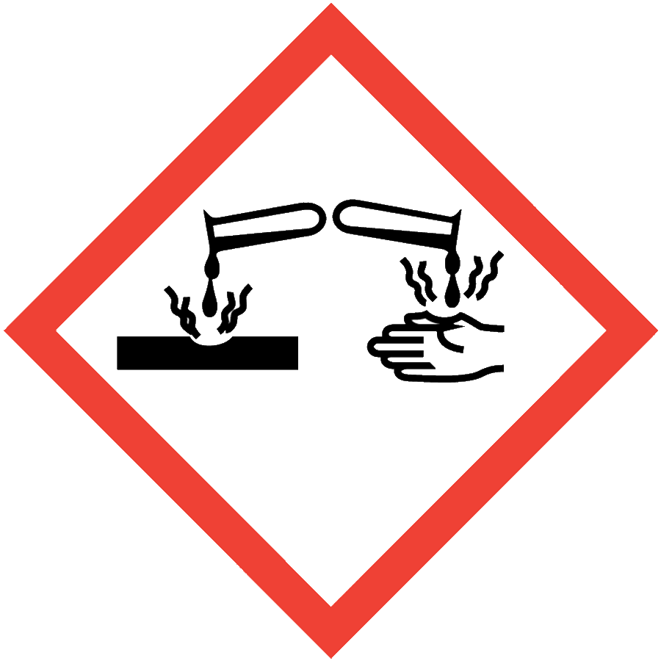
CORROSIVES
Corrosives can destroy living tissue and damage other substances (e.g., metals) by chemical action at the site of contact. Corrosives are commonly found in research laboratories and are used for multiple purposes. Common examples of corrosives include acids and bases. Corrosive chemicals such as hydrofluoric acid and nitric acid have additional hazards not covered in this SOP; these chemicals require chemical-specific SOPs.

ENGINEERING/VENTILATION CONTROLS
At minimum, adequate general laboratory ventilation must be provided to maintain exposure below safe regulatory limits.
Some corrosives present inhalation hazards or are particularly hazardous substances (i.e., carcinogens, acute toxicants and/or reproductive toxicants) and must be worked with in a chemical fume hood.
If Permissible Exposure Limits (PELs) may be exceeded, a chemical fume hood or other engineering control is required. PELs can be found in Section 8 of an SDS.

SAFE WORK PRACTICES
- Know the signs and symptoms of exposure to the material before working with it. (Consult the SDS.)
- Follow universal administrative controls described in the Chemical Hygiene Plan.
- Avoid all contact with corrosive chemicals. Use a fume hood if there is an inhalation hazard.
- When diluting, add acid or base to water.
- Wash hands thoroughly after handling corrosives.

PPE
- Eye Protection: ANSI Z87.1 safety glasses or goggles
- Body Protection: lab coat
- Hand Protection: protective gloves appropriate for the chemical being used (consult the SDS)
Depending on the risk assessment, a face shield and/or chemical splash apron may be appropriate. Additional PPE may be required if the chemical has additional hazard classification(s).

HANDLING AND STORAGE
- Keep containers closed when not in use.
- Ensure containers are in good condition and compatible with the material.
- Store corrosives upright and below eye level.
- Store liquid corrosives in secondary containers.
- Segregate incompatible materials:
  - Segregate acids from bases.
  - Segregate inorganic acids from organic acids and flammables.
  - Segregate all acids from reactive metals (e.g., sodium, potassium, magnesium).
  - Segregate acids from azides and cyanides to prevent adverse reactions.
  - Consult Sections 7 and 10 of the SDS for chemical-specific storage recommendations.

SPILL AND ACCIDENT PROCEDURE
Consult the Chemical Hygiene Plan for spill and accident procedures.
Some corrosives (e.g., hydrofluoric acid, phenol) have special incident response procedures that must be detailed in a laboratory-specific procedure.

DECONTAMINATION AND WASTE DISPOSAL
- Decontaminate work areas, fume hoods/gloveboxes and equipment while wearing proper PPE. Consult the SDS for decontamination procedures. Soap and water are effective for many materials.
- Neutralization of the corrosive contamination (e.g., using citric acid for bases or sodium bicarbonate for acids) may be needed prior to cleaning.
- Collect waste in chemically compatible containers labeled with a Seattle University Hazardous Waste Label.
- Segregate incompatible waste streams (e.g., acids from bases). Refer to Section 10 of the SDS for specific incompatibilities.
- Consult the Regulated Waste Management policy for more details on waste disposal. Specific disposal recommendations are available in the SDS.

