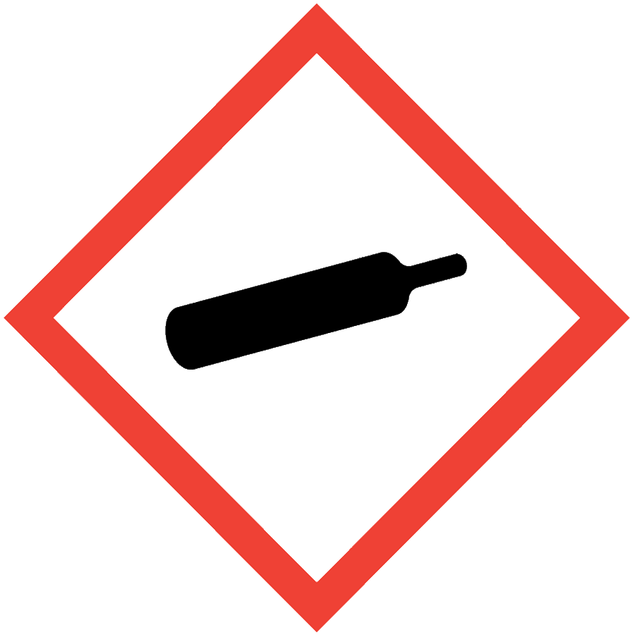
CRYOGENIC LIQUIDS

HAZARD CLASS DESCRIPTION
Cryogenic liquids have boiling points below -90 °C (-130 °F). Cryogenic liquids pose both health and physical hazards: they can cause frostbite; they have large volume expansion factors when they boil, which can over-pressurize sealed containers or piping; and their vaporization can displace oxygen and create an asphyxiation hazard in enclosed areas without sufficient ventilation. Specific cryogens have additional chemical reactivity considerations for safe handling. Common cryogenic liquids found in laboratories include liquid nitrogen, helium and oxygen.

ENGINEERING/VENTILATION CONTROLS
Use in a well-ventilated area. At minimum, adequate general laboratory ventilation must be provided to maintain exposure below safe regulatory limits.
Based on a risk assessment, oxygen monitors may be needed to prevent asphyxiation.

SAFE WORK PRACTICES
- Know the signs and symptoms of exposure to the material before working with it. (Consult the SDS.)
- Follow universal administrative controls described in the Chemical Hygiene Plan.
- Confirm that the cryogenic tank’s safety relief valves have not been modified. Under normal conditions, these containers will periodically vent product. Do not plug, remove or tamper with pressure relief devices.
- If attaching a dispensing hose,
  - Use a hose fitting appropriate for the dispensing valve (proper CGA number).
  - Tighten dispensing hose to the dispensing valve outlet before using.
- DO NOT use tools on cylinder valves.
- Choose chemically compatible materials designed for use with cryogens.
- Use tongs to immerse or remove items from cryogenic liquids. Never immerse hands, even if PPE is worn.

PPE
- Eye Protection: ANSI Z87.1 safety glasses or goggles
- Body Protection: lab coat
- Hand Protection: loose-fitting cryogenic gloves
- Face Protection: face shield
Additional PPE may be required if the chemical has additional hazard classification(s).

HANDLING AND STORAGE
- Maintain 20-foot separation between cryogenic oxygen and flammables/combustibles.
- Do not allow liquid oxygen to contact organic materials, flammables or combustible materials.
- Never allow any unprotected part of the body to contact uninsulated pipes or equipment containing cryogenic liquid.
- Store cryogenic liquid containers in a vertical position.
- Store cylinders in well-ventilated areas. Do not store in confined spaces.
- Transport cryogenic liquids secured to a suitable hand truck.
- Do not drop, tip or roll containers on their sides.
- Use a freight elevator to transport cryogens when available.
- Slowly open liquid dispensing valves on liquid cylinders to minimize splashing and boiling.
- Boiling and splashing always occurs when filling warm containers or inserting objects in cryogenic liquids. Stand clear of boiling and splashing.
- Only transfer cryogenic liquids into containers designed for use with cryogens.
  - Never place cryogenic liquids in a sealed container, including a refrigerator/freezer.
  - Use Dewar flasks with a cap that allows built-up pressure to escape and keeps air and moisture out.
  - Ensure that Dewar flasks are in good condition and are shielded or wrapped to contain fragments should implosion occur.
- Consult Sections 7 and 10 of the SDS for chemical-specific storage recommendations.

SPILL AND ACCIDENT PROCEDURE
Consult the Chemical Hygiene Plan for spill and accident procedures.
For liquid oxygen: Immediately remove clothing that has been splashed or soaked with liquid oxygen or exposed to high oxygen concentrations. Air clothing for at least an hour. Personnel should stay in a well-ventilated area and avoid any source of ignition until clothing is completely free of excess oxygen. Clothing saturated with oxygen is readily ignitable and will burn vigorously.

DECONTAMINATION AND WASTE DISPOSAL
Contact vendors to remove cryogen cylinders from the lab.

