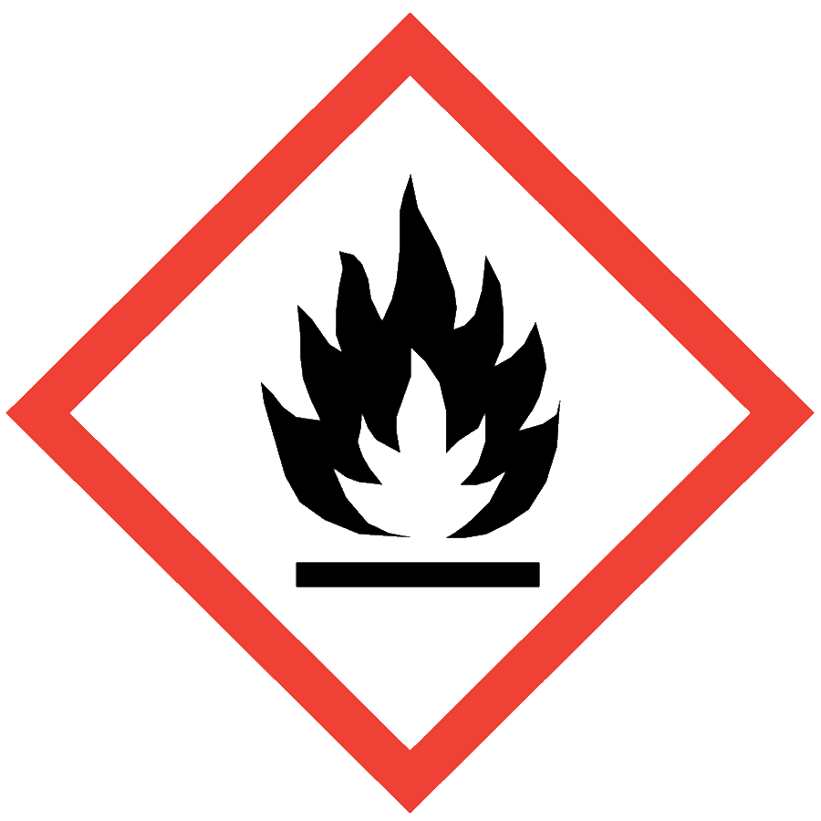
FLAMMABLE AND COMBUSTIBLE LIQUIDS

HAZARD CLASS DESCRIPTION
Flammable and combustible liquids can ignite and cause severe burns or death. Flammable liquids by definition have flash points below 100 °F; combustible liquids have flash points of 100–200 °F. Flash point information is located in Section 9 of a material’s SDS.
Most laboratories have some volume of flammable or combustible liquids in use or storage. These liquids have a variety of uses as solvents, reagents and cleaning solutions.

ENGINEERING/VENTILATION CONTROLS
At minimum, adequate general laboratory ventilation must be provided to maintain exposure below safe regulatory limits and help prevent the buildup of flammable vapors.
Some flammable and combustible liquids are particularly hazardous substances (i.e., carcinogens, acute toxicants and/or reproductive toxicants) and must be worked with in a chemical fume hood.
Never use flammable and combustible liquids in a biosafety cabinet unless it is ducted to the building ventilation system.
If Permissible Exposure Limits (PELs) may be exceeded, a chemical fume hood or other engineering control is required. PELs can be found in Section 8 of an SDS.

SAFE WORK PRACTICES
- Know the signs and symptoms of exposure to the material before working with it. (Consult the SDS.)
- Follow universal administrative controls described in the Chemical Hygiene Plan.
- Do not heat flammable liquids with an open flame.
- Avoid ignition sources such as heat guns, static electricity, Bunsen burners, etc.
- Avoid using equipment with exposed wiring.
- Clear the work area of all unnecessary combustible items (e.g., paper, Styrofoam).
- Ensure that metal containers are properly grounded.
- Know where to access and how to use a fire extinguisher. Ensure that a fire extinguisher is readily available (within 30 feet) and appropriate (minimum rated 40BC) for the materials in use.
- Wash hands thoroughly after handling flammable and combustible liquids.

PPE
- Eye Protection: ANSI Z87.1 safety glasses or goggles
- Body Protection: lab coat; avoid synthetic fibers and choose a flame-resistant option when the use of flammable and combustible liquids presents more than de minimis risk or when working around an ignition source
- Hand Protection: protective gloves appropriate for the chemical being used (consult the SDS)
Additional PPE may be required if the chemical has additional hazard classification(s).

HANDLING AND STORAGE
- Keep containers closed when not in use.
- Ensure that containers are in good condition and compatible with the material.
- Store flammable and combustible liquids in flammable liquid storage cabinets with self-closing hinges whenever
  - More than 10 gallons of flammables are stored in an area or
  - Containers exceed 1 gallon (4 L) capacity.
- Label flammable liquid storage cabinets “FLAMMABLE—KEEP FIRE AWAY.”
- Store only the amounts needed for the current procedure on benchtops.
- Keep storage locations clear of packaging material and other combustible materials.
- Use only refrigerators and freezers storing flammable liquids must be designed to store flammable liquids. These units must meet the requirements under NPFA 45 and NFPA 70. Household or standard refrigerators must not be used.
- Segregate incompatible materials. Flammable and combustible liquids must be kept away from oxidizers. Consult Sections 7 and 10 of the SDS for chemical-specific storage recommendations.

SPILL AND ACCIDENT PROCEDURE
Consult the Chemical Hygiene Plan for spill and accident procedures.

DECONTAMINATION AND WASTE DISPOSAL
- Decontaminate work areas, fume hoods/gloveboxes and equipment while wearing proper PPE. Consult the SDS for decontamination procedures. Soap and water are effective for many materials.
- Collect waste in chemically compatible containers labeled with a Seattle University Hazardous Waste Label.
- Segregate incompatible waste streams (e.g., flammables from oxidizers). Refer to Section 10 of the SDS for specific incompatibilities.
- Consult the Regulated Waste Management policy for more details on waste disposal. Specific disposal recommendations are available in the SDS.

