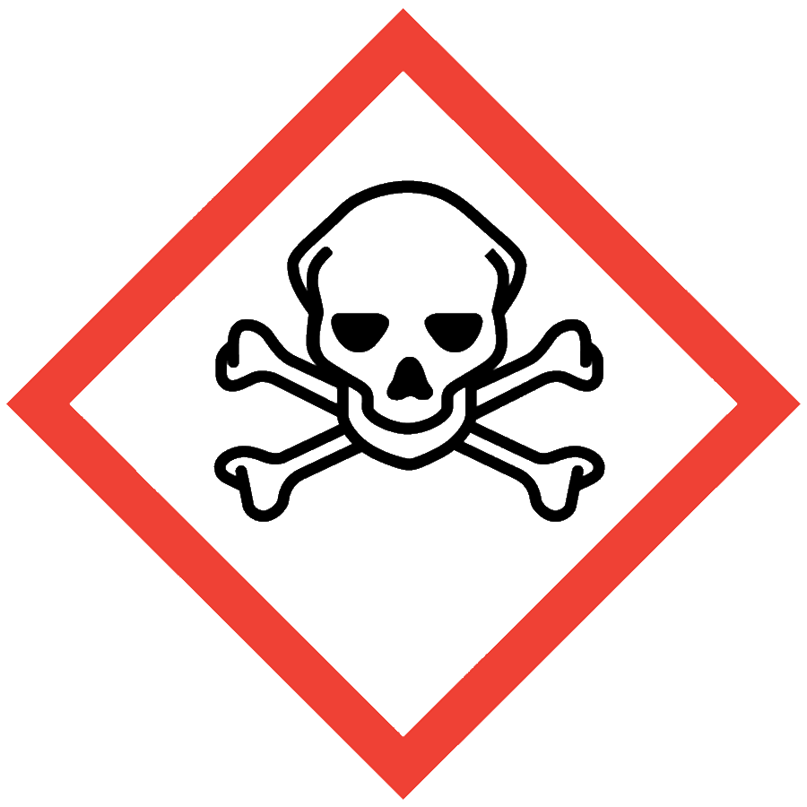
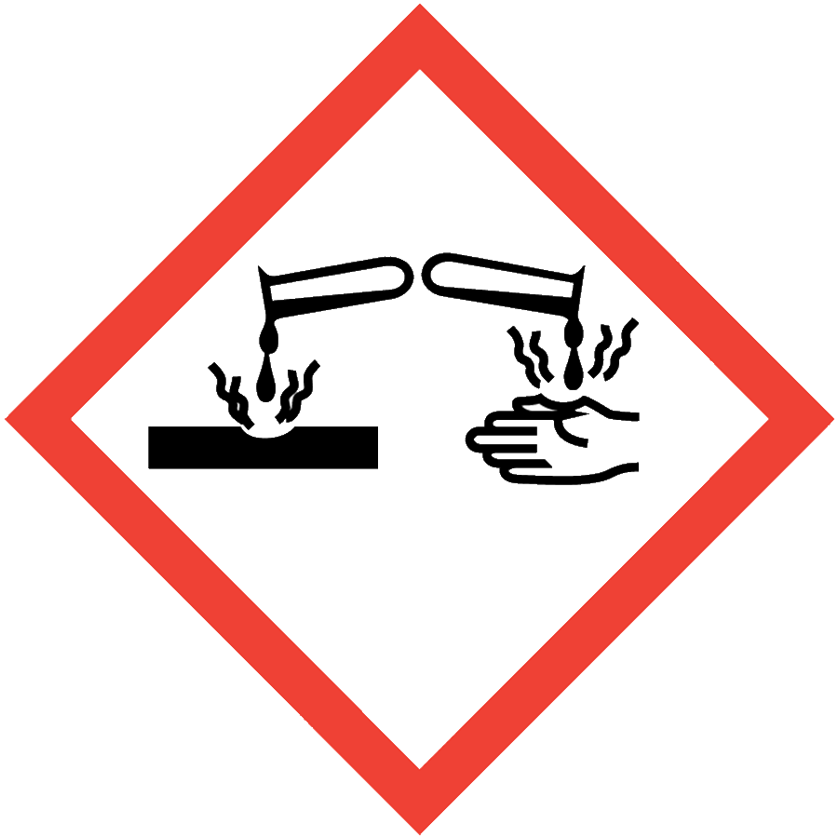
Osmium Tetroxide
Osmium tetroxide (OsO₄) is an acutely toxic and corrosive solid used for organic synthesis, electron microscopy and fixing biological samples. Osmium tetroxide can penetrate plastics and sublimes under standard conditions. Exposures through contact with the skin or eyes, inhalation or ingestion can be fatal. Osmium tetroxide will irreversibly stain the cornea, which can lead to blindness.

ENGINEERING/VENTILATION CONTROLS
- Chemical fume hood
If a process/experiment cannot be performed in a fume hood, contact the ASO for an assessment to determine necessary controls.

SAFE WORK PRACTICES
- Before beginning work, prepare an experiment plan that describes the safety considerations for each step of the process, including disposal (i.e., cradle to grave).
- Know the signs and symptoms of exposure to the material before working with it. (Consult the SDS.)
- Follow universal administrative controls described in the Chemical Hygiene Plan.
- Work with osmium tetroxide in a designated area.
- Minimize the amount of material handled.
- Avoid all contact with osmium tetroxide.
- Wash hands thoroughly after handling osmium tetroxide.

PPE
- Eye Protection: ANSI Z87.1 safety goggles
- Body Protection: lab coat
- Hand Protection: two pairs of Nitrile rubber gloves (consult the SDS for additional information)
Depending on risk assessment, a face shield and/or chemical splash apron may be appropriate. Additional PPE may be required if the process has additional hazards associated with it.

HANDLING AND STORAGE
- Store in glass at sub-ambient temperatures. Do not store in plastic.
- Store in a dry, well-ventilated area in leak-proof secondary containment.
- Segregate from incompatible materials, including reducing agents, oxidizing agents, organic materials, powdered metals and hydrochloric acid.
- Keep containers tightly closed when not in use to limit sublimation.
- Label containers and storage area with a hazard warning including a skull-and-crossbones pictogram and the word “Danger.”
- Minimize quantities in storage and use.
- Consult the SDS for additional chemical-specific storage recommendations.

SPILL AND ACCIDENT PROCEDURE
Osmium tetroxide spills are emergencies. Immediately notify others in the area and evacuate the location. Contact Public Safety at 206-296-5911. Do not attempt to clean the spill yourself.
Consult the Chemical Hygiene Plan for emergency spill and accident procedures.

DECONTAMINATION AND WASTE DISPOSAL
- Decontaminate work areas, fume hoods and equipment with soap and water while wearing proper PPE. Consult the SDS for additional decontamination procedures. Dispose of contaminated paper towels as solid hazardous waste.
- Collect waste in chemically compatible (glass) containers labeled with a Seattle University Hazardous Waste Label.
- Dispose of empty containers of osmium tetroxide and gloves/PPE or paper products that contacted osmium tetroxide as solid hazardous waste.
- Consult the Regulated Waste Management policy for more details on waste disposal. Specific disposal recommendations are available in the SDS.

