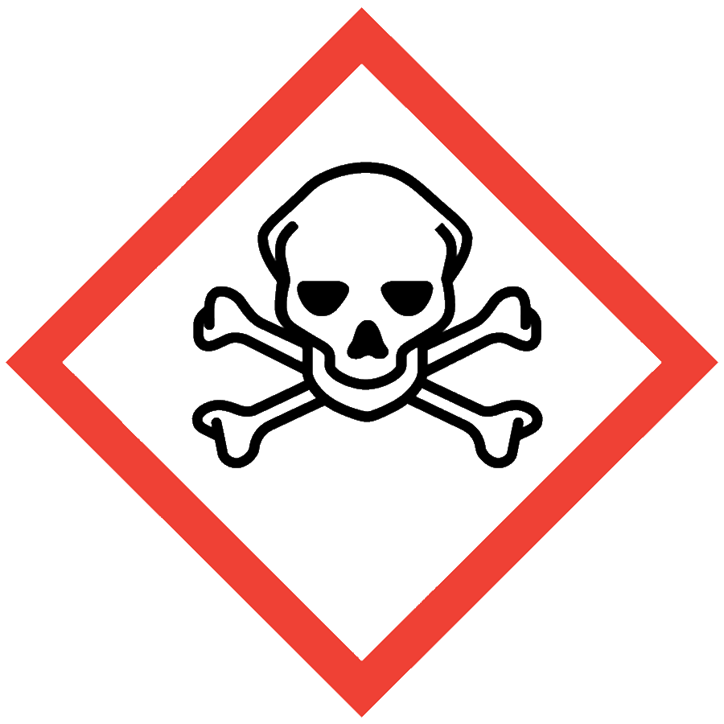
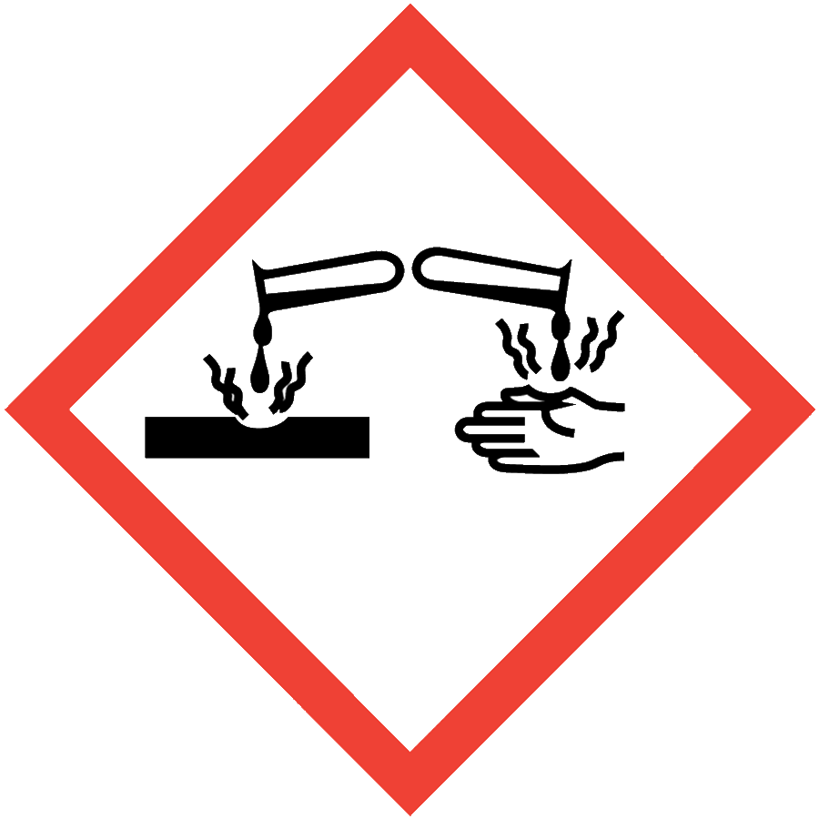
PHENOL

HAZARD CLASS DESCRIPTION
Phenol is toxic and corrosive. Phenol exposure can cause serious eye damage and skin burns. Skin exposures may go undetected for some time as phenol has some anesthetic properties (i.e., there is no immediate burning sensation). Long-term exposure may damage the liver or kidneys.

ENGINEERING/VENTILATION CONTROLS
- Chemical fume hood or glovebox
If the process/experiment cannot be performed in a fume hood or glovebox, contact the ASO for an assessment to determine necessary controls.

SAFE WORK PRACTICES
- Know the signs and symptoms of exposure to the material before working with it. (Consult the SDS.)
- Follow universal administrative controls described in the Chemical Hygiene Plan.
- Avoid all contact with phenol.
- Perform work in a fume hood since phenol presents an inhalation hazard.
- Monitor gloves closely to ensure that penetration or tearing have not occurred. Skin exposures may have no immediate symptoms.
- Wash hands thoroughly after handling phenol.

PPE
- Eye Protection: ANSI Z87.1 safety glasses or goggles
- Body Protection: lab coat
- Hand Protection: protective gloves appropriate for the chemical being used (consult the SDS)
Depending on the risk assessment, a face shield and/or chemical splash apron may be appropriate. Additional PPE may be required if the process has additional hazards associated with it.

HANDLING AND STORAGE
- Keep containers closed when not in use.
- Ensure containers are in good condition and compatible with the material.
- Store phenol in secondary containment, upright and below eye level.
- Segregate phenol from bases and any other incompatible materials. Consult sections 7 and 10 of the SDS for chemical-specific storage recommendations.

SPILL AND ACCIDENT PROCEDURE
Consult the Chemical Hygiene Plan for general spill and accident procedures. Phenol has the following chemical-specific exposure procedures:
Skin contact: Immediately remove contaminated clothing and wash the area with polyethylene glycol (PEG) 400 or a mixture of PEG 300 and ethanol (2:1) for 15 minutes. If neither is available, wash with excess water, using a safety shower if necessary, for 15 minutes. Call x5911 to report the incident and obtain medical attention.
Eye contact: Wash eyes using an emergency eyewash for 15 minutes. Call x5911 to report the incident and obtain medical attention.
A video covering phenol first aid response is available from Lawrence Berkeley Labs.

DECONTAMINATION AND WASTE DISPOSAL
- Decontaminate work areas, fume hoods/gloveboxes and equipment while wearing proper PPE. Consult the SDS for decontamination procedures.
  - If neutralization of corrosive contamination is needed before cleaning, use sodium bicarbonate.
  - Soap and water can be used after neutralization.
- Collect waste in chemically compatible containers labeled with a Seattle University Hazardous Waste Label.
- Segregate incompatible waste streams. Refer to Section 10 of the SDS for specific incompatibilities.
- Consult the Regulated Waste Management policy for more details on waste disposal. Specific disposal recommendations are available in the SDS.

