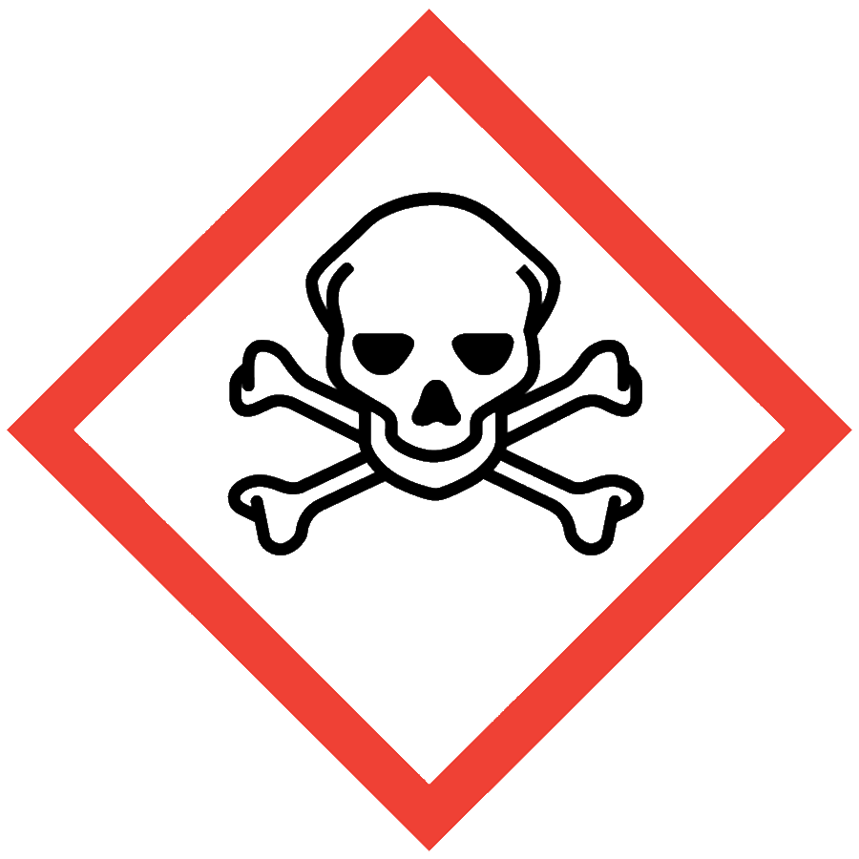
TOXIC CHEMICALS
Toxic chemicals can refer to chemicals with acute toxicity or chronic toxicity. Toxic materials may target a specific organ, e.g., substances that are hepatotoxins, nephrotoxins, neurotoxins or hematotoxins. In addition to organ-specific toxicities, toxic chemicals may have the following reported median lethal doses (LD₅₀) or median lethal concentrations (LC₅₀):
- Oral LD₅₀ >50 mg/kg but ≤300 mg/kg in rats
- Dermal LD₅₀ >200 mg/kg but ≤1000 mg/kg in rabbits
- Inhalation LC₅₀ >500 ppm but ≤2500 ppm (gas), >2 mg/L but ≤10 mg/L (vapor) or >0.5 mg/L but ≤1 mg/L (mist, fume or dust) when administered for 4 hours to rats
Toxicological information is available in Section 11 of a material’s safety data sheet (SDS).

ENGINEERING/VENTILATION CONTROLS
At minimum, adequate general laboratory ventilation must be provided to maintain exposure below safe regulatory limits.
If Permissible Exposure Limits (PELs) may be exceeded, a chemical fume hood or other engineering control is required. PELs can be found in Section 8 of an SDS.

SAFE WORK PRACTICES
- Know the signs and symptoms of exposure to the material before working with it. (Consult the SDS.)
- Follow universal administrative controls described in the Chemical Hygiene Plan.
- Limit the amount of material handled: use the smallest amount possible.
- Wash hands thoroughly after handling toxic substances.

PPE
- Eye Protection: ANSI Z87.1 safety glasses or goggles
- Body Protection: lab coat
- Hand Protection: protective gloves appropriate for the chemical being used (consult the SDS)
Additional PPE may be required if the chemical has additional hazard classification(s).

HANDLING AND STORAGE
- Keep containers closed when not in use.
- Ensure containers are in good condition and compatible with the material.
- Store liquid toxic chemicals in secondary containment.
- Consult Sections 7 and 10 of the SDS for chemical-specific storage recommendations.

SPILL AND ACCIDENT PROCEDURE
Consult the Chemical Hygiene Plan for spill and accident procedures.

DECONTAMINATION AND WASTE DISPOSAL
- Decontaminate work areas, fume hoods/gloveboxes and equipment after each use while wearing proper PPE. Consult the SDS for decontamination procedures. Soap and water are effective for many materials.
- Collect waste in chemically compatible containers labeled with a Seattle University Hazardous Waste Label.
- Segregate incompatible waste streams. Refer to Section 10 of the SDS for specific incompatibilities.
- Consult the Regulated Waste Management policy for more details on waste disposal. Specific disposal recommendations are available in the SDS.

