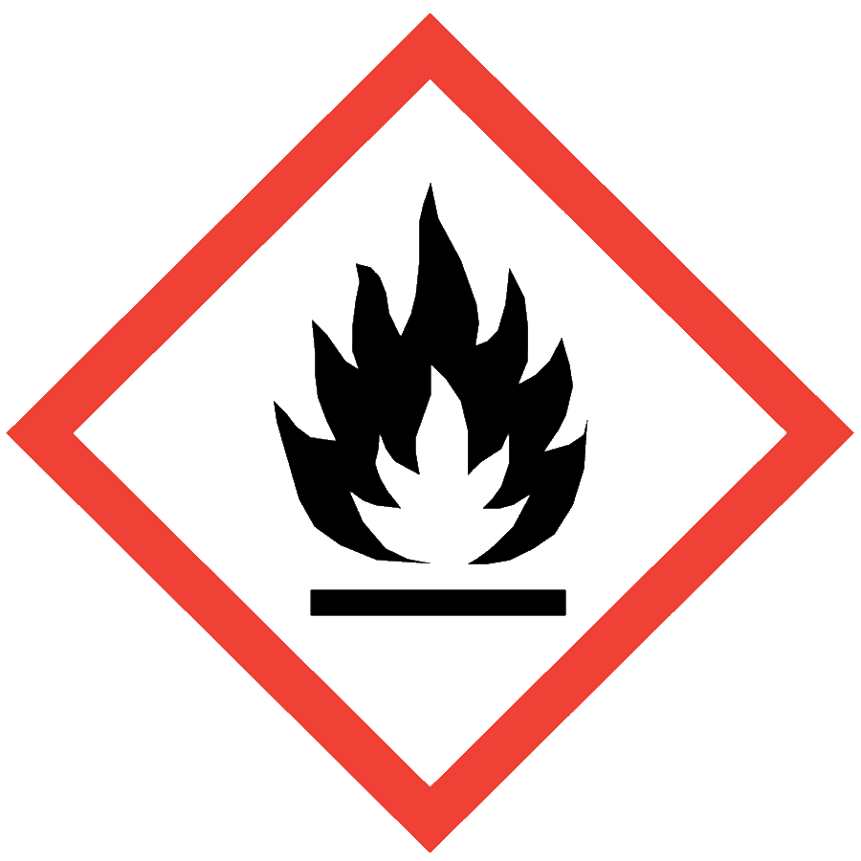
WATER-REACTIVE CHEMICALS
Water-reactive materials produce a toxic or flammable gas when exposed to water. The reaction can also produce heat, which can ignite the flammable gas and lead to fire. Some chemicals are so highly reactive with water that moisture in the air is sufficient to cause a violent reaction. Typical gases produced include H₂, CH₄ and other low molecular weight hydrocarbons.

ENGINEERING/VENTILATION CONTROLS
Adequate general laboratory ventilation must be provided to maintain exposure below safe regulatory limits. Water-reactive chemicals may require the use of gloveboxes and/or air- and water-free techniques for use and handling.
Water-reactive chemicals that are particularly hazardous substances (i.e., carcinogens, acute toxicants and/or reproductive toxicants) require the use of a glovebox or chemical fume hood.
If Permissible Exposure Limits (PELs) may be exceeded, a chemical fume hood or other engineering control is required. PELs can be found in Section 8 of an SDS.

SAFE WORK PRACTICES
- Follow universal administrative controls described in the Chemical Hygiene Plan.
- Know the signs and symptoms of exposure and the gases produced by reaction with water before working with the material.
- Remove unnecessary items and flammable or combustible materials from the work area before beginning work with water-reactive chemicals.
- Inspect any air-free seal on containers with highly reactive and unstable chemicals. If damaged, contact EHS for removal and disposal.
- Wash hands thoroughly before leaving the lab.

PPE
- Eye Protection: ANSI Z87.1 safety glasses or goggles
- Body Protection: lab coat; avoid synthetic fibers and choose a flame-resistant option when there is a risk of fire
- Hand Protection: protective gloves appropriate for the chemical being used (consult the SDS)
Additional PPE may be required if the chemical has additional hazard classification(s).

HANDLING AND STORAGE
- Keep containers closed when not in use.
- Ensure containers are in good condition and compatible with the material.
- Store in secondary containers away from incompatibles.
  - Storage in a desiccator or glovebox is strongly recommended.
  - Alkali metals and metal hydrides can be stored in mineral oil to keep them dry.
  - Consult Sections 7 and 10 of the SDS for chemical-specific storage recommendations.

SPILL AND ACCIDENT PROCEDURE
Consult the Chemical Hygiene Plan for spill and accident procedures.
Do not use water to put out a fire. Choose a dry chemical or Class D fire extinguisher. Contact the ASO for assistance identifying an appropriate fire extinguisher.

DECONTAMINATION AND WASTE DISPOSAL
- Decontaminate work areas, fume hoods/gloveboxes and equipment while wearing proper PPE. Consult the SDS for decontamination procedures. Avoid using water.
- Collect waste in chemically compatible containers labeled with a Seattle University Hazardous Waste Label. As long as they are safely contained, there is no need to quench water-reactive materials before disposal.
- Segregate incompatible waste streams (e.g., aqueous or acidic waste). Refer to Section 10 of the SDS for specific incompatibilities.
- Consult the Regulated Waste Management policy for more details on waste disposal. Specific disposal recommendations are available in the SDS.

