Investigating the Use of Treated Biochar for Arsenic Contaminated Drinking Water Remediation

Seattle University
Center for Environmental Justice and Sustainability
Gary L. Chamberlin Fellowship

Faculty Advisor
Dr. Phillip Thompson

Student Fellow
Piper Klinger

Introduction

Arsenic contamination of drinking water is a health issue for people around the world. In water, arsenic is usually found in its speciations of either arsenite (As(III)) or arsenate (As(V)) which are both highly toxic (Amen et. al 2020). It has also been known to infiltrate rice crops in South and Southeast Asia that are grown in contaminated water (Zhang et al. 2016). It is a confirmed carcinogen, and exposure can cause short-term and long-term health issues such as skin lesions, cirrhosis, and other chronic diseases (WHO, 2021 and Amen et. Al 2020). The World Health Organization (WHO) estimates that over 140 million people in 50 countries are exposed to arsenic contaminated drinking water above the recommended limit of 10 μg/L.

Because of the severity of arsenic contamination, many different remediation techniques have been developed. They range from physical, chemical, and biological, including nano-filtration, lime softening, and chemical precipitation, among others (Amen et. al, 2020). These techniques do have significant drawbacks, mainly that they are very expensive and require a lot of technical maintenance. Adsorption via treated biochar has been a recent field of interest, since it is cost-efficient and relatively simple, although more thorough research is needed to refine the techniques.

Biochar preparation and methods usually consist of crushing the substance and drying at a relatively low temperature (about 80°C). It then undergoes pyrolysis, which is heating between 550-750 °C with little to no oxygen present (Yakout et al. 2019, Amen et al. 2020, Wang et al. 2019). Biochar alone has some adsorption properties but is not capable of removing enough arsenate to meet desired levels. The biochar must be treated with another compound to improve the adsorption efficiency, although exact compounds differ between studies (Amen et al. 2020). Examples of treatment include nickel and manganese oxyhydroxides, iron impregnated biochar, and CaCO₃ treatment among others (Amen et al, 2020).

A study by Priyadarshni et al. examines risk husk biochar treated with stabilized iron and copper oxide nanoparticles for arsenic remediation and found that pH, contact time, and interfering ions would affect adsorption efficiency (Priyadarshni et al. 2020). A recent critical review of studies using biochar for arsenic remediation listed arsenic species, pyrolysis temperature, surface area, pH of the solution, and porosity of biochar as factors that would affect adsorption (Amen et al. 2020). It also emphasizes finding the correct dose of biochar for optimal adsorption, as too much could reduce the efficiency.

The purpose of this study was to continue testing the adsorptive properties of biochar in an attempt to develop a method that could be used in simple column filtration systems. It also aims to address the issue of poor indoor air quality resulting from inadequate ventilation when burning an open flame. The WHO estimates that 3 billion people around the world are exposed to dangerous indoor air quality, which can cause health issues such as pneumonia, stroke, COPD, and lung cancer (WHO 2018). This study uses cookstoves for pyrolysis that burn cleanly, so the solution can be two-fold. With the combination of cookstoves and the resulting biochar and remediation, this method aims to serve two purposes in which both indoor air quality is improved, and arsenate is removed from drinking water

Methods

Aspen flakes were used as the base material for the biochar. Pyrolysis was conducted in a high temperature (500°C to 600°C) TLUD cookstove until aspen chips were entirely charred (fig. 1).

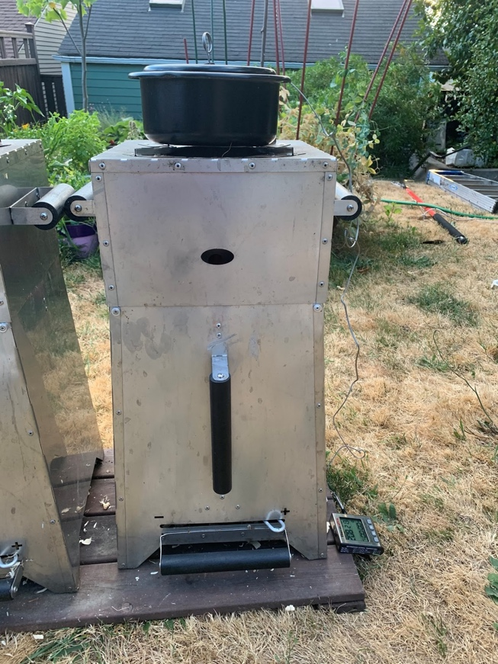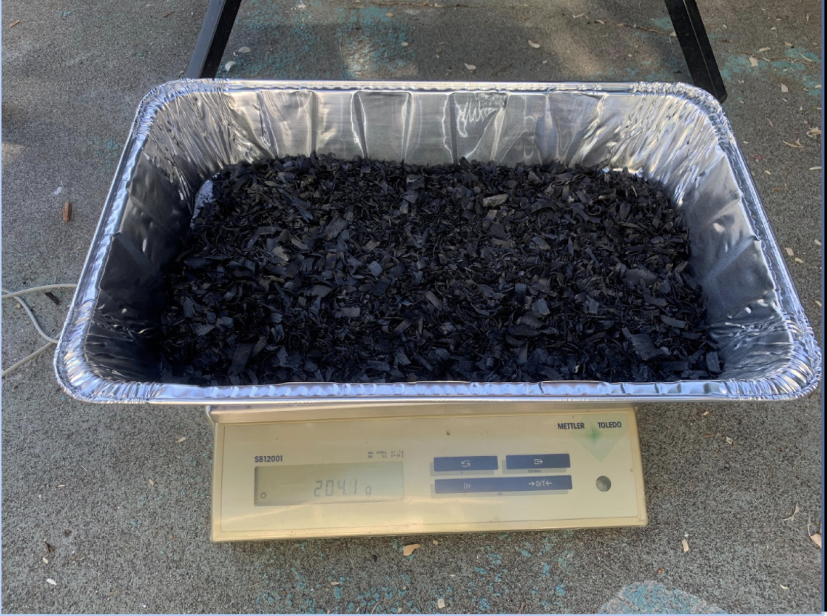
Figure 1. The TLUD cookstove (left) is used in the pyrolysis process to create biochar (right).

Once the biochar was created, it was soaked in a MgCl solution so that it would become activated and be better able to adsorb the arsenate. Once it was soaked and left in the sun to dry, it was then crushed using a mortar and pestle. The biochar was passed through 50mm, 20mm and 10mm sieves until it met the granular activated carbon (GAC) requirements set by the American Water Works association (Robinson & Hansen, 1974).

The adsorption efficiency was first tested in a column system to simulate field conditions. The column system from top to bottom was layered with 1/4” pea gravel, a layer of enhanced biochar, a steel mesh sheet, and a ceramic candle filter. Water that had been mixed with arsenate was poured through the column and filtered into a bucket. It was then sent for ICP-MS testing.

Results from the column tests were promising enough so that the method continued in the laboratory, where the adsorption of the activated biochar was tested in a range of quantities. The arsenate solution was prepared using a 1-L volumetric flask with 2-ml of the arsenate solution and filled with 1-L of DI water at pH 7.0. The amount of added biochar ranged from 1/8 teaspoon to 1.5 teaspoon, with three samples at each different amount. The weight of each sample was recorded. The approximately 40-ml of the arsenate solution was added to the test tube. The exact amount of solution was recorded as well.

The tubes were placed in a small box and put onto a shaker table at 100 rpm and 25°C for at least four hours. Afterwards, the samples were either left to settle for at least twenty-four hours or put on a centrifuge at speed three for five minutes. Once the samples had been settled, the solution was transferred to sample vials for ICP-MS testing to obtain the final concentrations of arsenate after treatment.

Results

The first set of results were from the initial column experiments run by Dr. Thompson (fig. 2). These show that the untreated biochar does have some soprtive properties but does not remove enough arsenate to meet the MCL of 10 ppb. The enhanced biochar was much more effective, but the final concentration was still at around 20 ppb. This proof of concept then lead to the lab experiments which sought to understand the optimal amount of biochar for adsorption.

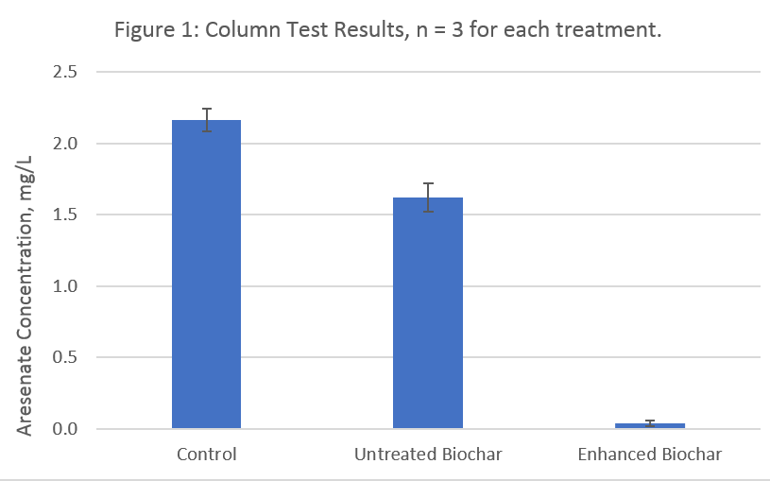
Figure 2: Column tests comparing untreated biochar and enhanced biochar.

In total there were three experiments in the lab with MgCl treated biochar. Figure 3 shows the linear isotherm from the first experiment. The first trial, conducted by Dr. Thompson, found that the MgCl biochar had a K_{d} value of 36.7 L/kg (fig. 3).

Figure 3: A linear isotherm for granular enhanced biochar and arsenate indicated a sorption coefficient K_{d} of 36.7 L/kg.

The following two experiments were conducted in an attempt to verify the K_{d} value. Experiment two had an adsorption coefficient of 50.1 L/kg (fig. 4). The trials from this experiment were averaged, since there were some outliers that otherwise would have skewed the data. Error bars are presented to show uncertainty with these averages.

Figure 4: Experiment two where the averaged MgCl treated biochar and arsenate linear adsorption isotherm has a K_{d} value of 50.1 L/kg.

Experiment three did not have any outliers, and the linear adsorption isotherm shows a K_{d} value of 53.4 L/kg (fig. 5). R values for all experiments indicate that the data is accurate and generally follows the linear trendline.

Figure 5: Experiment three where MgCl treated biochar and arsenate linear adsorption isotherm has a K_{d} value of 53.4 L/kg

From these three experiments, the average K_{d} value is 46.7 L/kg. We assume that this adsorption coefficient must be between approximately 36-50 L/kg.

Discussion and Conclusions

Results from the initial column test were able to show the potential for MgCl treated biochar adsorption. That test served as a proof of concept. This is promising since the column method will be what is used in the field for household scale remediation, although further trials with the column method are still needed.

The average K_{d} value from the three experiments was 46.7 L/kg. When scaling this adsorption coefficient up to a column test, this would mean that roughly one kilogram of biochar could treat up to 500 liters of water, resulting in a cost of $0.25 per liter of water. This cost is estimated from using the MgCl treatment.

There will be further experiments using MgSO₄, or Epsom salts, as the treatment since it is easier to obtain and cheaper than MgCl. In theory, MgSO₄ should also be an effective adsorptive enhancement since the positively charged Mg⁺ ion would still be present. Using the same methods as the MgCl tests, it would be beneficial if an effective K_{d} value could be found for MgSO₄. This would make biochar adsorption even more accessible and easier to use. Further tests will also include more column tests, as well as exploring the use of biochar for fluoride remediation.

References
Amen, R., Bashir, H., Bibi, I., Shaheen, S., Niazi, N., Shahid, M., Hussain, M., Antoniadis, V., Shakoor, M., Al-Solaimani, S., Wang, Hailong., Bundschuh, J., and Rinklebe, J. (2020) A Critical Review on Arsenic Removal from Water Using Biochar-Based T Sorbents: The Significance of Modification and Redox Reactions. Chemical Engineering Journal, vol. 396, 2020, doi:https://doi.org/10.1016/j.cej.2020.125195.
Arsenic. (2021). World Health Organization, World Health Organization, www.who.int/en/news-room/fact-sheets/detail/arsenic.
Household Air Pollution and Health (2018) World Health Organization, World Health Organization. https://www.who.int/news-room/fact-sheets/detail/household-air-pollution-and-health
Niazi, N., Bibi, I., Shahid, M., Sik Ok, Y., Burton, E., Wang, H., Shaheen, Sabry., Rinklebe, J., Luttge, A., (2018). Arsenic Removal by Perilla Leaf Biochar in Aqueous Solutions and Groundwater: An Integrated Spectroscopic and Microscopic Examination. Environmental Pollution, vol. 232, 2018, pp. 31–41., doi:https://doi.org/10.1016/j.envpol.2017.09.051.
Priyadarshni, N., Nath, P., Nagahanumaiah, Chanda, N. (2020) Sustainable Removal of Arsenate, Arsenite and Bacterial Contamination from T Water Using Biochar Stabilized Iron and Copper Oxide Nanoparticles and Associated Mechanism of the Remediation Process.” Journal of Water Process Engineeering, vol. 37, 2020, doi:https://doi.org/10.1016/j.jwpe.2020.101495 .
Robinson, J., Hansen, E. (1974) AWWA Standard for Granular Activated Carbon AWWA B604-74 (First Edition).
Wang, S., Gao, B., Li, Y., Creamer, A., He, F. (2019) Adsorptive Removal of Arsenate from Aqueous Solutions by Biochar Supported Zero-Valent Iron Nanocomposite: Batch and Continuous Flow Tests. Journal of Hazardous Materials, vol. 322, 2019, pp. 172–181., doi:https://doi.org/10.1016/j.jhazmat.2016.01.052.
Yakout, S., Salem, N., Mostafa, A., Abdeltawab, A. (2018) Relation between Biochar Physicochemical Characteristics on the Adsorption of Fluoride, Nitrite, and Nitrate Anions from Aqueous Solution. Particulate Science and Technology, vol. 37, no. 1, 2019, pp. 118–122., doi:https://doi.org/10.1080/02726351.2017.1352633.
Zhang, F., Wang, X., Xionghui, J., Lijuan, M. (2016) Efficient Arsenate Removal by Magnetite-Modified Water Hyacinth Biochar. Environmental Pollution, vol. 216, 2016, pp. 575–583., doi:https://doi.org/10.1016/j.envpol.2016.06.013.

